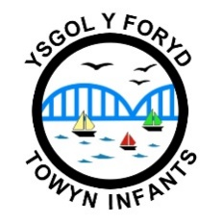
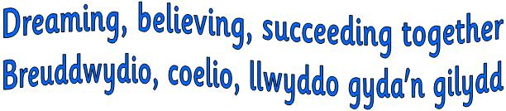

YSGOL BABANOD Y FORYD

(Towyn Infants School)

Morfa Avenue, Kinmel Bay, Conwy LL18 5LE
Tel/Fax: 01745 351892 email: pennaeth@yforyd.conwy.sch.uk
Website: www.yforyd.co.uk
Headteacher: Mrs Nicola Rowlands

Required for September 2023

ADDITIONAL LEARNING NEEDS LEVEL 1 TEACHING ASSISTANT

(permanent)

Salary: Grade G01 NJC point 2-3 £11,937.81 - £12,154.48 per annum
Hours: 25 hours per week term time plus 5 training days

The Governing Body at Ysgol y Foryd are pleased to share an opportunity for an Additional Learning Needs Level 1 teaching assistant to join our excellent team. The ability to work with children who have additional learning is important, and must be able support pupils to reach their potential, both emotionally and academically.

The successful candidate will join a happy, positive and highly successful school which benefits from having a highly professional and dedicated team of teachers and support staff.

Due to the nature of the posts the successful candidates will be subject to
a disclosure by the Disclosure and Barring Service.

It is a requirement that successful candidate will need to register with the Education Workforce Council prior to commencing employment

If you would like to discuss the post, please contact Mrs Hannah Williams on 01745 351892

To apply for this vacancy, please visit www.conwy.gov.uk/jobs to apply online.
Please note the authority no longer issues application forms and does not accept CVs.

If not informed within 3 weeks of the closing date, candidates must assume they have not been shortlisted for interview and will therefore not be notified in writing.

In promoting equal opportunities Conwy welcomes applicants from all sections of the community. All disabled applicants who meet the essential job requirements will be guaranteed an interview.

